**Week 3 Spring core and Maven**

**Exercise 1: Configuring a Basic Spring Application**

pom.xml

<project xmlns="http://maven.apache.org/POM/4.0.0" xmlns:xsi="http://www.w3.org/2001/XMLSchema-instance" xsi:schemaLocation="http://maven.apache.org/POM/4.0.0 https://maven.apache.org/xsd/maven-4.0.0.xsd">

<modelVersion>4.0.0</modelVersion>

<groupId>com.library</groupId>

<artifactId>LibraryManagement</artifactId>

<version>0.0.1-SNAPSHOT</version>

<name>LibraryManagement</name>

<dependencies>

<!-- Spring Core -->

<dependency>

<groupId>org.springframework</groupId>

<artifactId>spring-context</artifactId>

<version>5.3.36</version>

</dependency>

</dependencies>

</project>

applicationContext.xml

<?xml version="1.0" encoding="UTF-8"?>

<beans xmlns="http://www.springframework.org/schema/beans"

xmlns:xsi="http://www.w3.org/2001/XMLSchema-instance"

xsi:schemaLocation="http://www.springframework.org/schema/beans

http://www.springframework.org/schema/beans/spring-beans.xsd">

<!-- BookRepository Bean -->

<bean id="bookRepository" class="com.library.repository.BookRepository" />

<!-- BookService Bean -->

<bean id="bookService" class="com.library.service.BookService">

<property name="bookRepository" ref="bookRepository" />

</bean>

</beans>

BookRepository.java

**package** com.library.repository;

**public** **class** BookRepository {

**public** **void** saveBook(String bookName) {

System.***out***.println("Book saved: " + bookName);

}

}

BookService.java

**package** com.library.service;

**import** com.library.repository.BookRepository;

**public** **class** BookService {

**private** BookRepository bookRepository;

**public** **void** setBookRepository(BookRepository bookRepository) {

**this**.bookRepository = bookRepository;

}

**public** **void** addBook(String bookName) {

System.***out***.println("Adding book in service...");

bookRepository.saveBook(bookName);

}

}

MainApp.java

**package** com.library;

**import** com.library.service.BookService;

**import** org.springframework.context.ApplicationContext;

**import** org.springframework.context.support.ClassPathXmlApplicationContext;

**public** **class** MainApp {

**public** **static** **void** main(String[] args) {

ApplicationContext context = **new** ClassPathXmlApplicationContext("applicationContext.xml");

BookService bookService = (BookService) context.getBean("bookService");

bookService.addBook("The Alchemist");

}

}

**OUTPUT:**

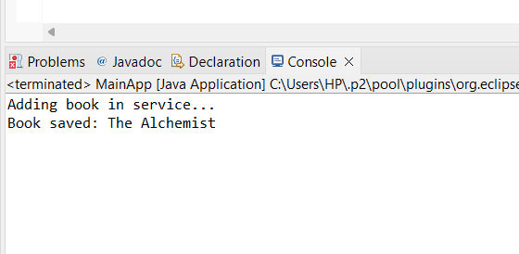

**Exercise 2: Implementing Dependency Injection**

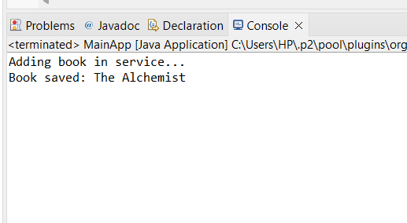Dependency Injection is working!

**Exercise 4: Creating and Configuring a Maven Project**

**pom.xml**

<project xmlns="http://maven.apache.org/POM/4.0.0" xmlns:xsi="http://www.w3.org/2001/XMLSchema-instance" xsi:schemaLocation="http://maven.apache.org/POM/4.0.0 https://maven.apache.org/xsd/maven-4.0.0.xsd">

<modelVersion>4.0.0</modelVersion>

<groupId>com.library</groupId>

<artifactId>LibraryManagementApp</artifactId>

<version>0.0.1-SNAPSHOT</version>

<name>LibraryManagementApp</name>

<dependencies>

<!-- Spring Context -->

<dependency>

<groupId>org.springframework</groupId>

<artifactId>spring-context</artifactId>

<version>5.3.36</version>

</dependency>

<!-- Spring AOP -->

<dependency>

<groupId>org.springframework</groupId>

<artifactId>spring-aop</artifactId>

<version>5.3.36</version>

</dependency>

<!-- Spring Web MVC -->

<dependency>

<groupId>org.springframework</groupId>

<artifactId>spring-webmvc</artifactId>

<version>5.3.36</version>

</dependency>

</dependencies>

<build>

<plugins>

<plugin>

<groupId>org.apache.maven.plugins</groupId>

<artifactId>maven-compiler-plugin</artifactId>

<version>3.10.1</version>

<configuration>

<source>1.8</source>

<target>1.8</target>

</configuration>

</plugin>

</plugins>

</build>

</project>

Created and Configured Maven project